***Rock, Paper, Scissors***

**Project Description**

This project consists of creating a Rock, Paper, Scissors game by using Python. The user will be prompted to input one of three options: rock, paper, or scissors. The computer will choose one option at random. Then, both choices will be compared to determine who wins the game.

**Languages and Utilities used**

Python

Visual Studio Code

**Program walk-through:**

***Import the module***



Before starting, I imported the random module to use different tools inside it to randomize computer’s actions the game.

**Take user input**



This will prompt the user to enter a selection and save it to the user_action variable for later use. Now that the user has selected an action, the computer needs to decide what to do.

**Make computer choose**



A list containing all three possible choices is created and stored in the possible_actions variable. Then, a random element is selected from the list by using the random.choice() method, which will be stored in the computer_action variable.

**Determine a winner**

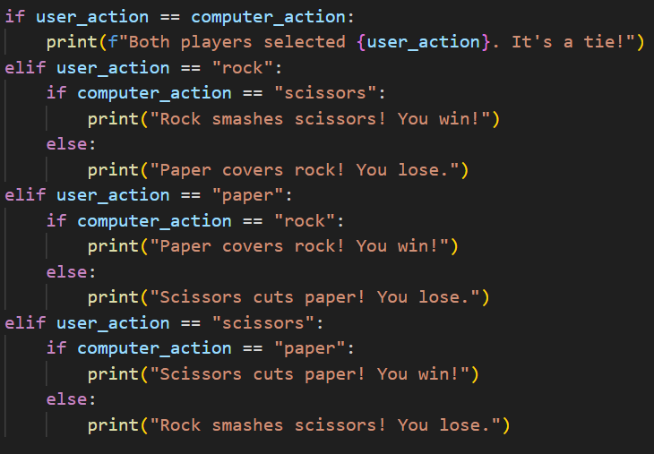

Using an if, elif, and else block, I can compare players’ choices and determine a winner. By comparing the tie condition first, I get rid of quite a few cases. If I didn’t do that, then I would’ve needed to check each possible action for user_action and compare it against each possible action for computer_action. By checking the tie condition first, I’m able to know what the computer chose with only two conditional checks of computer_action. A corresponding message is displayed depending on the results.